Issues #1656 and #6921 were fixed by simple additions to the code.

Issue #1656 was fixed with the following additions to animations.py file



Along with the following addition to figure.py file.



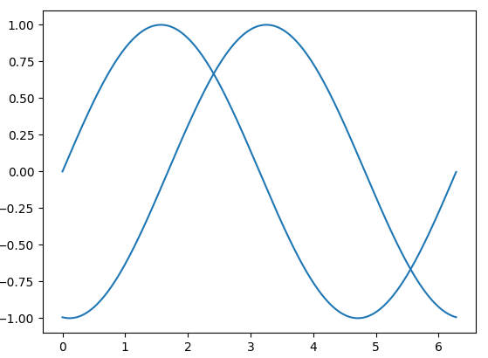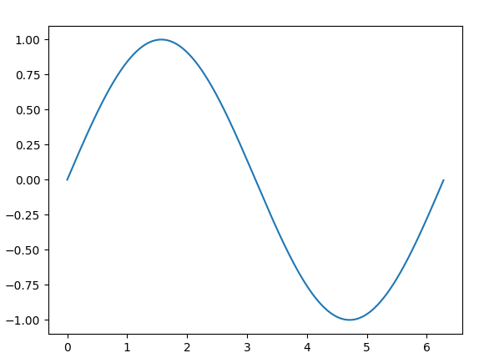

Before these fixes were implemented by us, the following error was present (i.e. animation is not being rendered).

After the fixes this is what the result looks like.

For you, the user, to confirm that the fix has been implemented you can run the following code we have provided. However, before you do that, we are assuming you have the necessary dependencies of matplotlib and matplotlib itself installed, as well as python.

To test our fix you need to open test_issue1656.py in your IDE or run it through the command line.

To reproduce the problem you can run the file reproduce_issue1656.py.

Issue #6921 was fixed with the following additions to legend_handler.py file



Before these fixes were implemented by us, the following error was present:

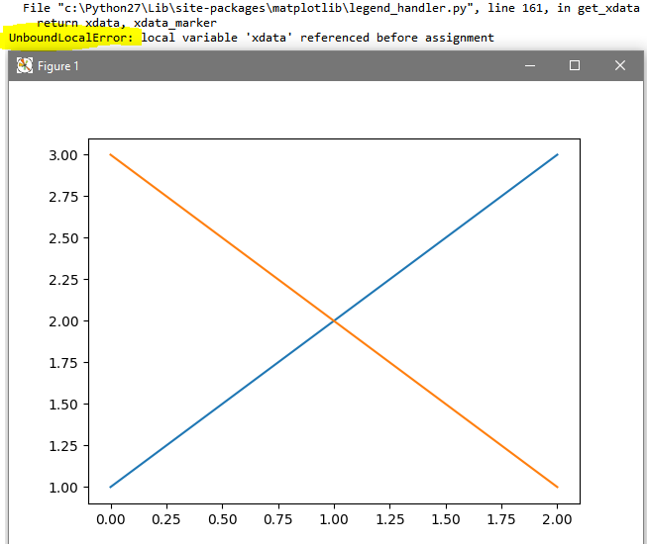

After the fix was implemented the following error is raised when the user input is invalid



To test our fix you need to open test_issue6921.py in your IDE or run it through the command line.

To reproduce the problem you can run the file reproduce_issue6921.py.